A picture containing clipart

Description generated with very high confidence

Azure 103 Module 4

Hands On - 3

Azure Certification Training

[**support@intellipaat.com**](mailto:support@intellipaat.com)

**+91-7022374614**

**US: 1-800-216-8930(Toll Free)**

**Azure 103 Module 4 , Hands On – 3**

**Verify VNET Connectivity**

**Step 1:** Connect to both virtual machines using RDP (Remote Desktop Protocol). (Open the VM Page, click on connect and download the RDP file. Then login using credentials set during VM creation).

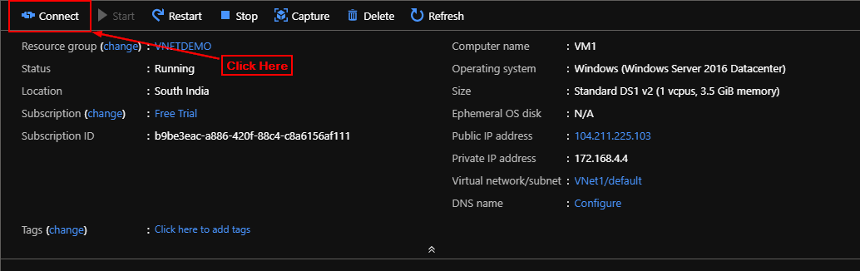

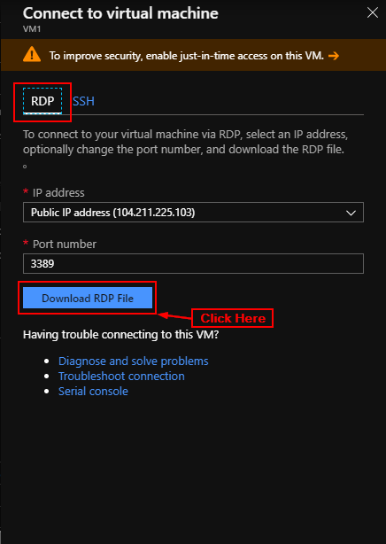

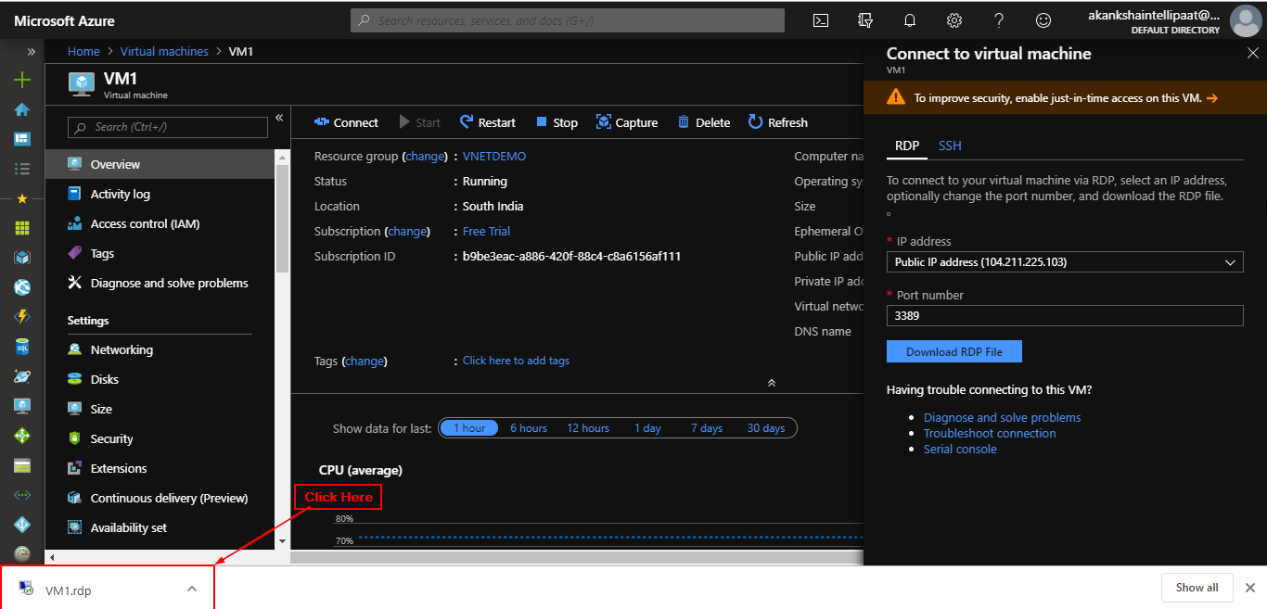

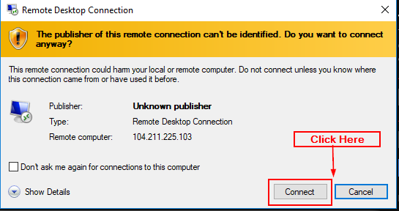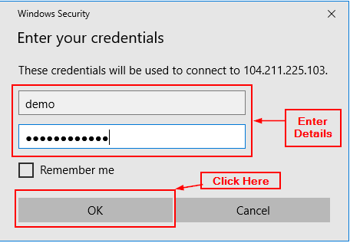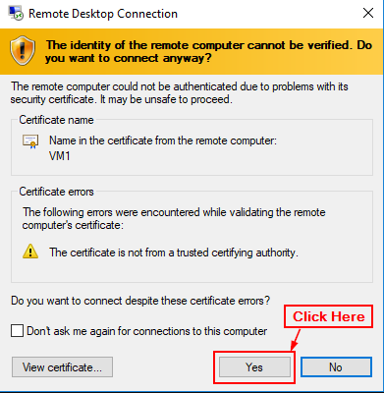

**Step 2:** Disable firewalls in both VM's (to allow ping command to run).

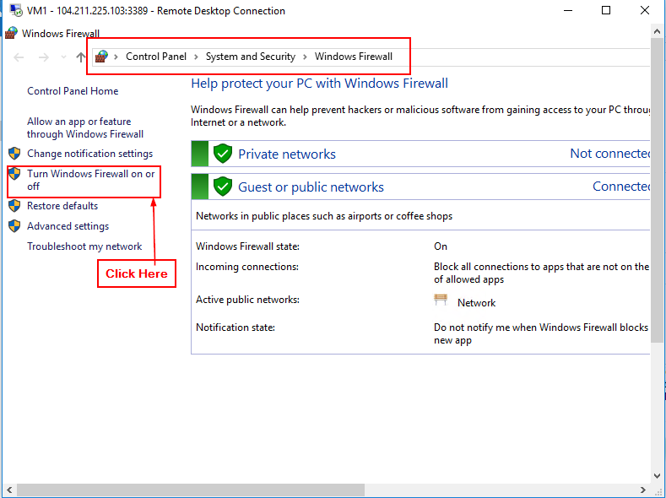

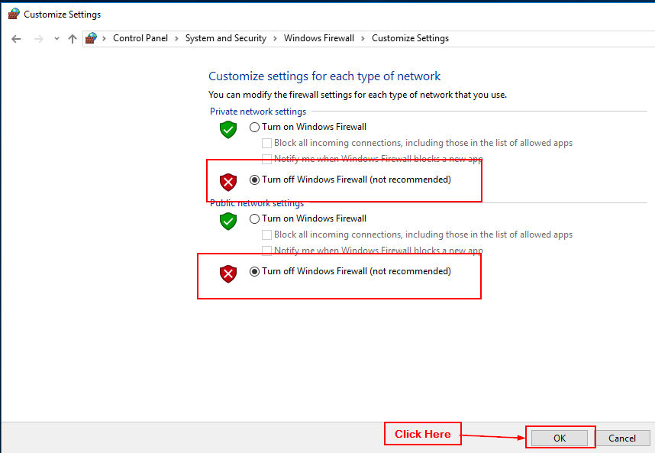

**Step 3:** Get the public IP addresses of the VM's (Open all settings > Go to Network and Internet > Click on Ethernet > Click on change adapter setting > Right Click on Ethernet > click on status > Click on details > Note down the IPV4 address).

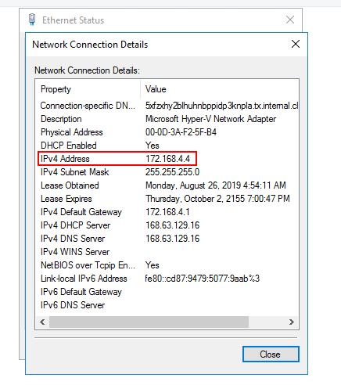

**Step 4:** Open CMD in the other VM. Type command 'ping IP -t' [Change IP with the IP of the other VM you are trying to ping]. Notice that you get a reply from the server.

